# Home Automation - Electricity Monitor Tutorial 1

## Building a light sensor to notify you when your electricity is running low

**Table of Contents**

1. Introduction 2

2. Hardware requirements 2

3. Preparing the SD Card 3

4. Hardware setup 3

5. Setting up the Raspberry Pi from initial boot 6

6. Coding Part 1 - Getting started with a simple LED test 8

7. Connecting the breadboard to the ArduPi 10

8. Coding Part 2 - LDR/Sensor Code 10

9. Coding Part 3 - Sending a Text Message through the internet 11

10. Coding Part 4 - Combining Part 1 and 2 15

11. Installation of the final product. 20

12. Helpful links 22

### 1. Introduction

Welcome to this tutorial. Just as a first note, during this tutorial I will be using some technical jargon, and will assume you know some of it. I will however explain a lot of the jargon as we go along. the assumption is also made that you have at least some working knowledge of hardware, Linux systems. This is not a must however and you will be able to complete this tutorial along side your new best friend Google. With that out of the way. If you are anything like me, I constantly forget to keep track of the status of my electricity usage and when it starts running low. The result of this is that more often than I dare admit, I get a frustrated call from my wife to tell me that the power has just gone off. Now if you life in South Africa, or if you have in the last 5 years or so you might argue that this is due to loadshedding, but alas it’s just my forgetfulness. The big frustration in this situation is not the calls I receive, but when the electricity runs out when nobody is at home and all my fridges and server at home goes for hours without electricity.

To remedy this situation, I set out to extend my home automation to include a sensor that will be triggered when my electricity supply runs low and then notifies me via text message to my mobile. Going about a project like this can be done in a couple of ways. I decided to make use of a Raspberry Pi as base system for project. Although the project will require the usage of a micro controller, the sending of text messages and capability to adapt or expand the project without redoing everything will require a bit of more power and flexibility hence the Raspberry Pi.

Due to the project requiring the usage of at least one sensor, I still faced the decision of what road to take when implementing the sensor into the project. Using the Raspberry Pi left me with three main options. Make use of the built in GPIO, add a. Arduino shield, or attach an Arduino board. Although there are certainly advantages to all three scenarios, I decided to go ahead and add an Arduino Shield to my Raspberry Pi. This will allow me the best of both world. The power and flexibility of the Raspberry Pi as well as the stability and low overhead of the Arduino.

### 2. Hardware requirements

After mapping out my requirements, I ended up with the following list of hardware components.

* Raspberry Pi (I used the Raspberry Pi Type B)
* USB Cable/ Charger or power adapter that will be used to power the Raspberry Pi
* SD Card
* WiFi Dongle (Optional if you have a network cable within reach of where your Prepaid Electricity meter) - If you do make use of a WiFi dongle, make sure that the one you decide on is compatible with your Raspbery Pi. In the links section of this document you can find more information on compatible dongles and how to install them.
* Arduino Shield (I used an ArduPi)
* Keyboard, Mouse, HDMI Cable, Monitor (These will be used during setup and programming, but will not be required after installation of the components after the setup has been completed.)
* Light Dependant Resistor (LDR) - Although you can choose from a variety of LDRs, I used a 11k LDR. This specific LDR only allows for around 0.5m accuracy which is perfect for this project due to the fact that the sensor will be positioned up close and personal in conjunction with my prepaid power meter.
* Breadboard (This project can be completed without the usage of a breadboard, but for expansion capability I decided to rather make use of one)
* 10k ohm resistor
* Wires (At least 4 will be required.)
* LED light
* heatshrink tube

### 3. Preparing the SD Card

To start of we will be required to install an operating system (OS) on the SD Card to be used within the Raspberry Pi. Luckily the Raspberry Foundation has this step covered quite well and we can simply head over to the Raspberry Foundation website to choose the OS of our choice and then follow the instructions on the site to get it set up on our SD Card. Probably the most widely used OS is Rasbian. This is also the OS I will be using for this project. To install Rasbian on the SD Card, you can either download the NOOBS OS installer program or if you prefer doing it yourself, you can go ahead and download the Rasbian image and then follow the installation instructions.

### 4. Hardware setup

Once you have your SD Card prepared, it is time to go ahead with the assembly of the hardware.

Start off by attaching your Arduino Shield to your Raspberry Pi. As mentioned above, I will be making use of an ArduPi and therefore refer to it going forward. If you decide on a different Arduino Shield or rather connecting a stand alone Arduino Board via USB to your Raspberry Pi, it will be up to you to make sure with the manufacturer of the board or community on how integration between the Raspberry Pi needs to take place.

Something to note of when making use of a shield like the ArduPi is to be aware of the voltage switch (if it contains one). Using the wrong voltage may result damage not only to the sensors and various other attachments, but may also cause damage to your shield and Raspberry Pi. After attaching your ArduPi to your Raspberry Pi, insert your wifi donlge into one of the USB ports.

Now lets start adding the other components into your breadboard. Although any coloured wires can be used, I like to stick to a bit of a standard. So taking that into account I will be making use of coloured wires red, black (x2) and yellow.

Before we start connecting up the components, let’s quickly take a look at the breadboard and how it is used.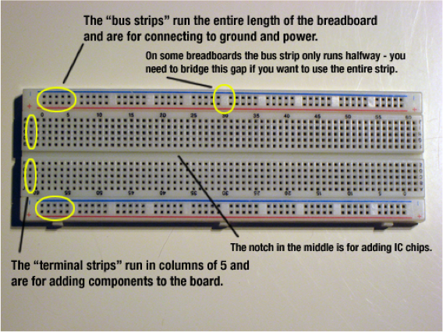

As seen in the picture above the breadboard is numbered numerically from left to right and then alphabetically from top to bottom. In this project I will be making use of a smaller breadboard than that shown above. Instead the breadboard I will be using has 30 rows across and 12 rows down

(marked A - L). Take note of the picture above and how the bus strips work. The bus strip only runs halfway, so make sure that when you insert your wires that they are inserted in the same half or else it will not work. For this project I decided to make use of the right half of the bus strip, so my first black and red wires are inserted into pin 17. Now that we understand how the breadboard works, connect the red wire to the positive row on the bus strip and the black wire to the negative or ground row. The second black wire is inserted into the far right pin, pin 30 on my board, of the negative row on the bus strip in-line with the first black wire. The other end of the second wire is to be inserted into pin L30 of the terminal strips

Next insert the one side of your resistor into pin 28 of the positive row on the bus strip and the other into pin L28 on the terminal strips. The next step will be to connect the LDR into the circuit. Due to the sensitivity of LDRs, care and planning will be required when inserting it into the board. To aid in optimal performance of the LDR, I decided to have it face to the side of the breadboard and in the direction of the prepaid meter. To achieve this, I bent the legs on the LDR 90 degrees, offsetting the two bents by about half a centimetre. This allows the LDR to be placed into the breadboard without the two wires touching or being entangled.The first leg was inserted int pin G30 and the second into H28. With that done, the only thing left to connect is the last wire. Insert the last wire, yellow in my case, one side into pin K30 of the terminal strip This concludes the component on the breadboard. Don’t be alarmed that the breadboard is not connected to the ArduPi at this stage. We will hook up the now loose hanging sides of the red, black and yellow wires to the ArduPi later in this tutorial.

Your final layout should look something like the below:

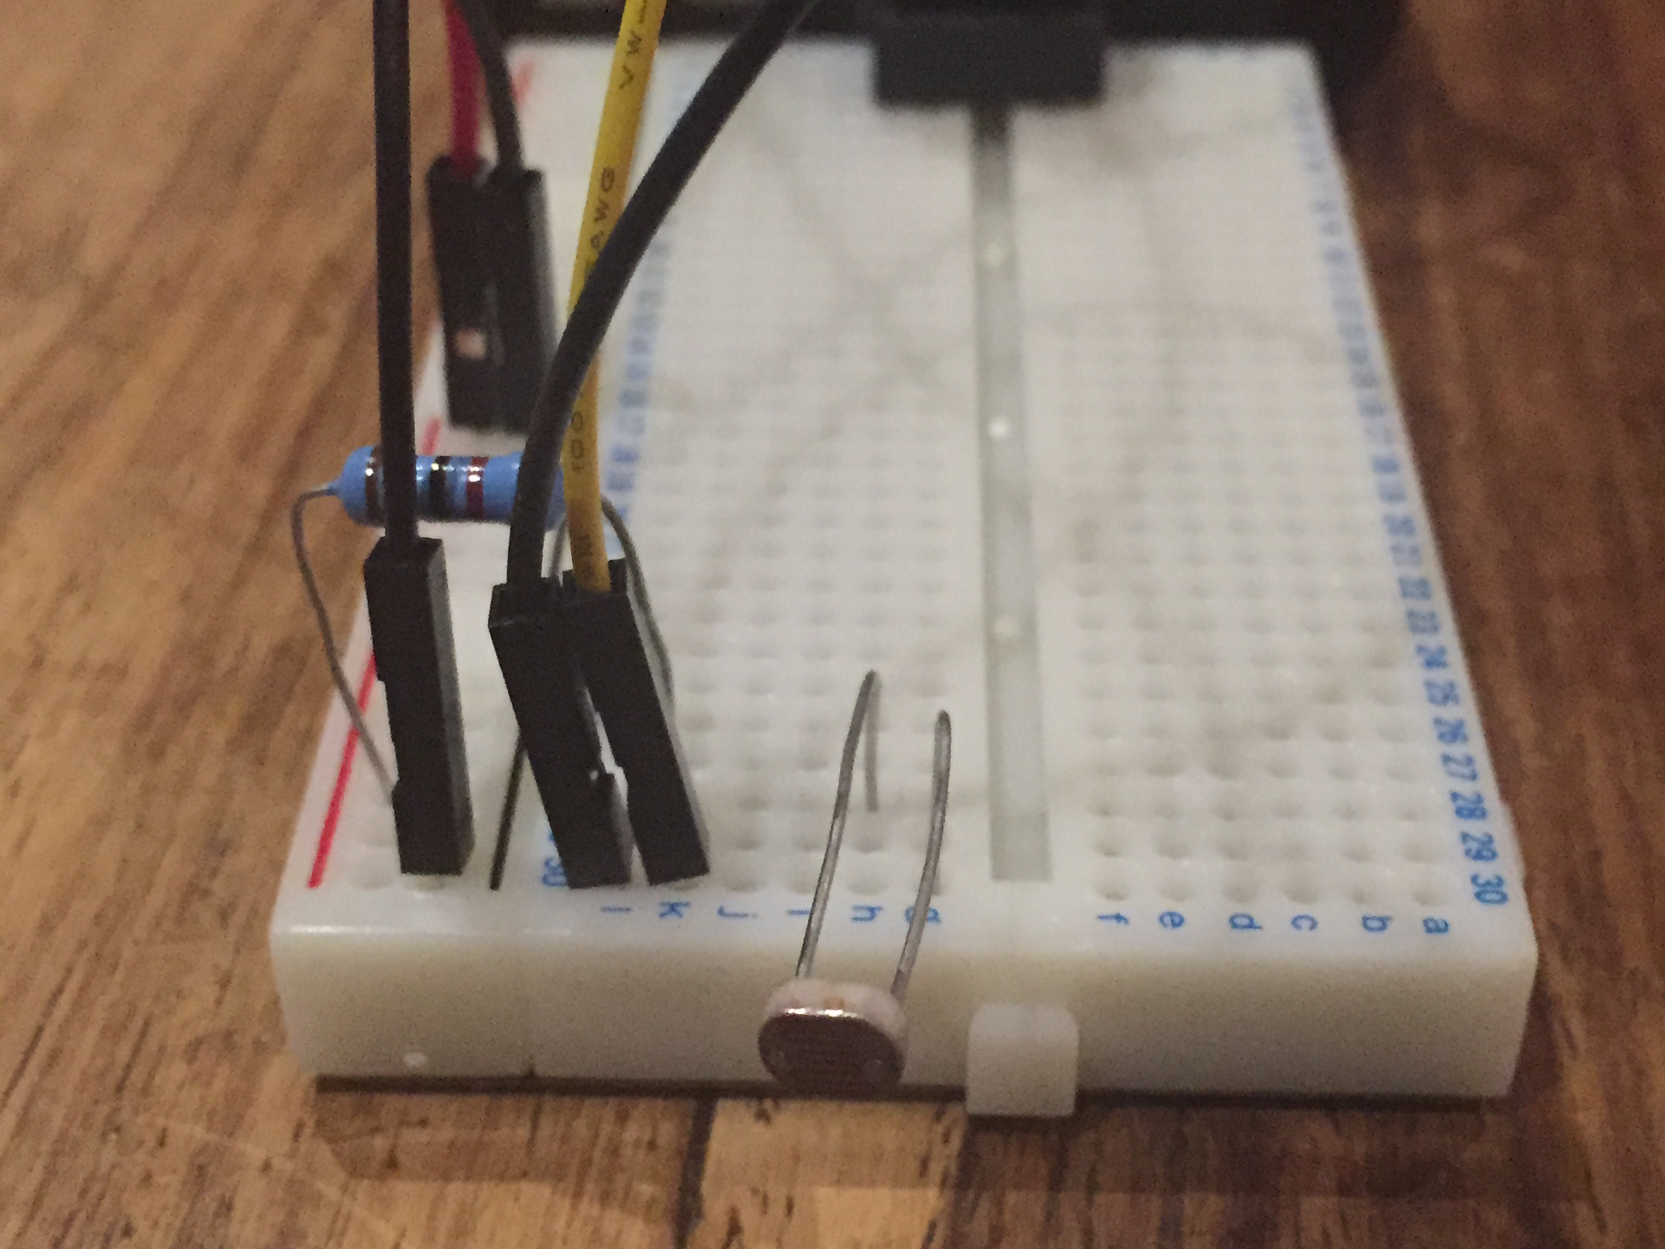

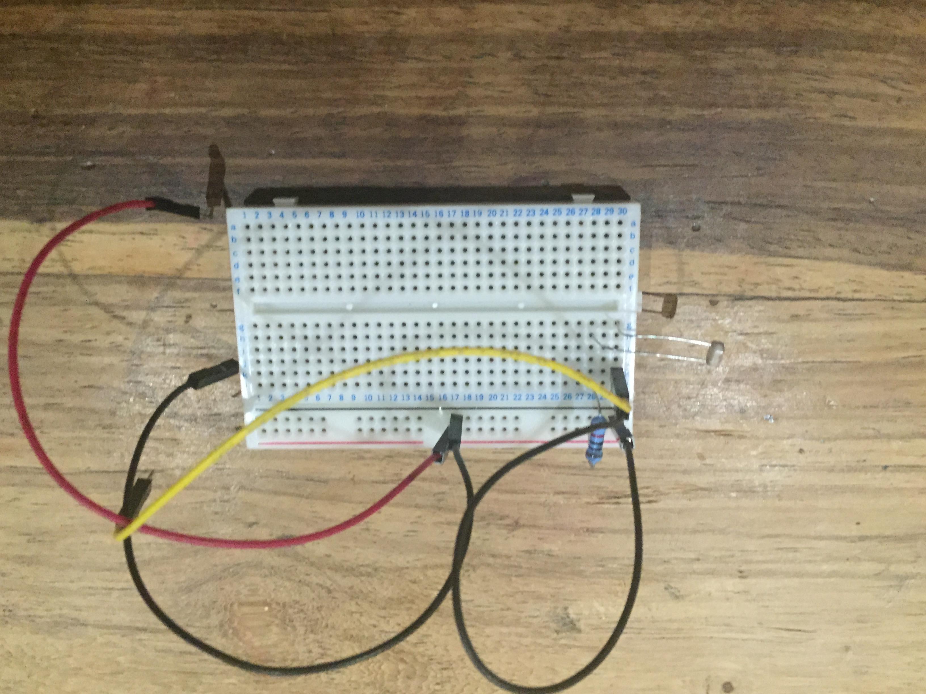

### 5. Setting up the Raspberry Pi from initial boot

Now that the components are in place, insert your SD Card into your Raspberry Pi and add your Keyboard, mouse, HDMI Cable and Monitor. It is now time to boot up the Raspberry Pi. To save time, I strongly recommend to make use of a network cable at this stage. The main reason behind this is to ensure that your WiFi dongle is working and to save time during setup and initial downloads. In the event that you choose to make use of the NOOB installation, you will first be required to choose the OS you would like to have installed. Once selected, click on the install button and wait for the installation to be completed. After the installation is done, please reboot the device.

As mentioned I will be using Rasbian, so the rest of this section will take only setup on Rasbian into account.

On initial boot of the Rasbian OS, you will be presented with a small options menu (If you are prompted to insert a login username and password. The default username and password for Rasbian is pi : raspberry). First thing you will need to do is to expand Rasbian to make use of the entire SD card storage. If you used NOOBS this will already be done for you. Next you need to enable the SSH protocol and change the default boot sequence from command line to GUI interface. You are also welcome to change the default password as well as update the locale and even overclock your Raspberry Pi. Please note that anything you change other than what is required is done so out of your own free will and you alone can be held accountable in the event that one of the settings damages your hardware or yourself.

If all is done with the initial setup, reboot your pi again and wait for the GUI interface to load. Once loaded, you can make sure that your WiFi dongle is working and setup. Now that the hardware is ready, we need to install the arduino package and arduPi library inside the raspberry-pi board. We can do this by either working directly on the Pi itself or by SSH from your computer. If you work from your Pi, open LX Terminal. Alternatively if you decide to go with the SSH route, open the terminal on your computer and then use the SSH command to connect to your Pi.

SSH Example: *ssh pi@IpAddressOfPi*

When you are prompted for the password, you enter either the default password of raspberry or if you changed it during the initial setup insert that password.

Once you are in the command line for your Pi, let’s get our hands dirty.

I always like to start form the root directory. To get there type

***pi@raspberrypi******~ $*** *cd /*

Just to be sure we have all the latest packages, let’s go ahead and run an update

***pi@raspberrypi******/ $*** *sudo apt-get update*

Now that that’s done, we can go ahead and install the Arduino package

***pi@raspberrypi******/ $*** *sudo apt-get install arduino*

Select Y when prompted : Do you want to continue [Y/n]?

After the package has been installed, we need to check that the Java package was also installed.

***pi@raspberrypi******/ $*** *java -version*

Your output should be in the lines of

*java version "1.8.0"*

*Java(TM) SE Runtime Environment (build 1.8.0-b132)*

*Java HotSpot(TM) Client VM (build 25.0-b70, mixed mode)*

Next we move on to installing the ArduPi library. First lets navigate back to our home directory.

***pi@raspberrypi******/ $*** *cd ~*

Create a directory called arduPi and then navigate to it. This will also serve as our project folder, so you can name this what ever you like and place it in a different directory.

***pi@raspberrypi******~ $*** *mkdir arduPi*

***pi@raspberrypi******~ $*** *cd arduPi*

Time to download the library

***pi@raspberrypi******~/arduPi $*** *wget* [*https://www.cooking-hacks.com/media/cooking/images/documentation/raspberry_arduino_shield/arduPi_1-5.tar.gz*](https://www.cooking-hacks.com/media/cooking/images/documentation/raspberry_arduino_shield/arduPi_1-5.tar.gz)

***pi@raspberrypi******~/arduPi $*** *ls*

***arduPi_1-5.tar.gz***

***pi@raspberrypi******~/arduPi $*** *tar -zxvf arduPi_1-5.tar.gz*

*arduPi_template.cpp*

*arduPi.h*

*arduPi.cpp*

As seen above, the fully extracted library contains three files. In order to compile and run our code we will be required to install g++.

***pi@raspberrypi******~/arduPi $*** *sudo apt-get install g++*

if g++ is already installed by the time you run the above installation, you might want to do an upgrade to the latest version to be sure your compiler works.

***pi@raspberrypi******~/arduPi $*** *sudo apt-get upgrade g++*

*Do you want to continue [Y/n]? y*

***pi@raspberrypi******~/arduPi $*** *g++ -c arduPi.cpp -o arduPi.o*

***pi@raspberrypi******~/arduPi $***

If the last g++ compiler command runs without errors, then your compiler is successfully set up.

We are going to turn off the UART as a serial console in order to let it be available for us. For safety make a backup of the /boot/cmdline.txt file.

***pi@raspberrypi******~/arduPi $*** *sudo cp /boot/cmdline.txt /boot/cmdline_backup.txt*

Then pen the file /boot/cmdline.txt:

***pi@raspberrypi******~/arduPi $*** *sudo nano /boot/cmdline.txt*

This file contains something similar to this (the content may vary):

dwc_otg.lpm_enable=0 console=ttyAMA0,115200 kgdboc=ttyAMA0,115200 console=tty1 root=/dev/mmcblk0p2 rootfstype=ext4 elevator=deadline rootwait

Remove the parameters that reference the UART serial port (ttyAMA0) so that it looks something like:

dwc_otg.lpm_enable=0 console=tty1 root=/dev/mmcblk0p2 rootfstype=ext4 elevator=deadline rootwait

exit and save the file. Next open the file /etc/inittab:

***pi@raspberrypi******~/arduPi $*** *sudo nano /etc/inittab*

Find this line (it should be at the end of the file):

T0:23:respawn:/sbin/getty -L ttyAMA0 115200 vt100

If not already so, comment it with a “#” symbol in the beginning of the line so that it looks like:

#T0:23:respawn:/sbin/getty -L ttyAMA0 115200 vt100

Exit and save the file, then reboot the Raspberry Pi. It is also recommend to enable SPI and I2C in the main setup. This can be done by running the raspi-config again

***pi@raspberrypi******~/arduPi $*** *sudo raspi-config*

Go to Advanced Options and open “A6 SPI”. Click “Yes” and “Ok” to all.

Repeat this process for both “A7 I2C” and “A8 Serial” under the Advanced Options

Now go to Finish and select “Yes” to reboot.

This concludes the required setup for the Raspberry Pi and ArduPi.

### 6. Coding Part 1 - Getting started with a simple LED test

Time for some basic testing. Just to make sure that your ArduPi library is working in conjunction with your Raspberry Pi, ArduPi and OS setup, we will first do a small blink test. This test will also serve as introduction to the codebase. If you are a C programmer, then you will have the home field advantage going forward. This is due to Arduino programming being done in the C programming language.

Before we can start writing out first test code, we will first need to hook up the LED ligth directly onto the ArduPi. You will note that the LED light has two legs, whereof the one is slightly longer than the other. The longer leg of the two is positive and the other negative. go ahead and insert the negative leg into the GND (ground) pin and the longer, positive, leg into pin 13 on the digital input strip of the ArduPi.

With that done, you can return to the terminal window.

We will use the blink.cpp from arduino’s sketches example like below. Soemthing to remember, is that although your ArduPi will allow you the capability of an arduino board, it is not so the behaviour will be slightly different. This is due to the fact that the ArduPi making use of the g++ library and therefore it likes running the code from scratch. To remedy this, we must put the main() function inside the code like below. First we will create the file within the project folder and then add the blink test code.

***pi@raspberrypi******~/arduPi $*** *vi blink.cpp*

Copy and paste code below into the blink.cpp file and save

#include "arduPi.h"

int main () {

setup() ;

while(1) {

loop() ;

}

return 0;

}

int led = 13;

void setup() {

pinMode(led, OUTPUT);

}

void loop() {

digitalWrite(led, HIGH); // turn the LED on (HIGH is the voltage level)

delay(1000); // wait for a second

digitalWrite(led, LOW); // turn the LED off by making the voltage LOW

delay(1000); // wait for a second

}

***pi@raspberrypi******~/arduPi $*** *ls*

***arduPi.cpp******arduPi.h*** *arduPi.o* ***arduPi_1-5.tar.gz******arduPi_template.cpp*** *blink.cpp*

***pi@raspberrypi******~/arduPi $***

The above sample code starts by including the arduPi.h library file. It then continues by initialising the main function and in it run both the setup and loop functions. Below the main function we set the variable led. This contains the pin to be used in the code to controll the LED light.

Within the setup function we set the pinMode. In this case we set the pin 13 to output. Next we add the actual functionality that will be output to the LED light within the loop function. In this code the light will be switched on for 1 second and then switched off. After another 1 second, the loop will restart.

To run this program we will first need to compile the code and then execute the compiled file.

***pi@raspberrypi******~/arduPi $*** *g++ -lrt -lpthread blink.cpp arduPi.o -o blink*

***pi@raspberrypi******~/arduPi $*** *ls*

***arduPi.cpp******arduPi.h*** *arduPi.o* ***arduPi_1-5.tar.gz******arduPi_template.cpp******blink*** *blink.cpp*

***pi@raspberrypi******~/arduPi $***

You will note that a new file called blink has now been added. It is this compiled file that we will execute. To execute the file run the below command

***pi@raspberrypi******~/arduPi $*** *sudo ./blink*

Once you are satisfied with result, you can stop the script from running by pressing ctrl + c

### 7. Connecting the breadboard to the ArduPi

So earlier we connected all the components to the breadboard. Before we add our code for the sensor, we now need to connect the breadboard up with the ArduPi. First remove the LED light we used for the blink test. You will remember that we had 3 wires left to connect. All of these wires will be added to the analog side of the ArduPi. First take the black wire and add it to the GND (ground) pin. Now take the red wire and connect it to the 3v3 pin. Lastly take the yellow wire and add it to pin 5.

Let’s start coding.

### 8. Coding Part 2 - LDR/Sensor Code

Now that we know that our ArduPi is working and have hooked up our breadboard to the ArduPi, we are ready to start with the coding for our sensor. As before we will create a new file.

***pi@raspberrypi******~/arduPi $*** *vi LightSensor.cpp*

Copy and paste code below into the LightSensor.cpp file and save

//Include ArduPi library

#include "arduPi.h"

//Include the Math library

#include <math.h>

#define TH 690

/*********************************************************

* IF YOUR ARDUINO CODE HAS OTHER FUNCTIONS APART FROM *

* setup() AND loop() YOU MUST DECLARE THEM HERE *

* *******************************************************/

/**************************

* YOUR ARDUINO CODE HERE *

* ************************/

int main (){

setup();

while(1){

loop();

}

return (0);

}

void setup(void) {

}

void loop(void){

float analogReadingArduino;

analogReadingArduino = analogRead(5);

if(analogReadingArduino > TH){

printf("Getting lighter\n");

} else {

printf("Getting darker\n");

}

delay(3000);

}

in the code above, we start off by including a couple of things, after which we define a global variable called TH and set it to 690. Then as before we have the main function that fires off the setup and loop functions. The setup function is empty and the loop function contains the logic for the sensor. First we set the set a variable for reading the sensor data and link it to pin 5 on the analog side of the ArduPi, Next we have a conditional statement that checks the reading received from the sensor and if the reading is smaller than the value of TH then we print out a message “Getting lighter”. Alternatively we print out “Getting darker”. To end the loop function we add a delay of 3 second to the loop function. This means that the loop function will wait for 3 seconds each time before running the function again.

Go ahead save the file and exit. Now we will compile the file and run it to check that it is working.

***pi@raspberrypi******~/arduPi $*** *g++ -lrt -lpthread LightSensor.cpp arduPi.o -o lightsensor*

***pi@raspberrypi******~/arduPi $*** *sudo ./lightsensor*

Depending on the ambient light in the room, you will either see **Getting lighter** or **Getting darker**. While the program is running try playing with the different levels of ambient light, by switching lights on and off, or by shining a flash light into the sensor and then turning it off. If you want to see the value being passed by the LDR you can also add the following line of code into the above file just before the if(analogReadingArduino > TH) statement:

printf(**"%g - "**, analogReadingArduino);

At this point you might start wondering about the effect the ambient light might have on the effectiveness of your sensor. So to make sure your sensor only picks up your red light, I suggest you add a piece of heatshrink around your sensor. A further suggestion would be to make your piece of heatshrink about 3cm or so longer than required to cover the sensor. This way you can position the sensor directly in front of the light or even have the open end of the heatshrink cover the red light. By doing this you will be absolutely sure that the sensor only picks up your red light.

Remember to heat the heatshrink up a bit on the sensor side so that it shrinks nicely around the sensor to remove any excess ambient light from behind the sensor.

### 9. Coding Part 3 - Sending a Text Message through the internet

In order to send your text message to your mobile phone you either need a GSM shield or seeing as you already have an internet connection linked up to your Raspberry Pi via WiFi Dongle or Ethernet cable, you might as well use an online gateway to do this for you.

In this tutorial we will be making use of an online gateway to handle our messaging needs.

Clickatell offers a wide variety of products and services. What makes them very appealing is the fact that they have a bunch of ready to use sample code.

We will start off by heading over to the Clickatell site and registering a Developer Central account.

Once the account has been activated and credits purchased, we can head over to the API section. By default on registration a HTTP API is automatically created for you. We will just go ahead an make use of this API to integrate into our project. The default username and password for the API is the same as your account credentials. Alternatively you can change it.

With the account set up, it is time to get a copy of their c library already created and ready to go.

***pi@raspberrypi******~/arduPi $*** *git clone https://github.com/clickatell/clickatell-c.git clickatell*

***pi@raspberrypi******~/arduPi $*** *ls*

***LightSensor*** *LightSensor.cpp* ***arduPi.cpp******arduPi.h*** *arduPi.o* ***arduPi_1-5.tar.gz******arduPi_template.cpp******blink*** *blink.cpp* ***clickatell***

***pi@raspberrypi******~/arduPi $*** *cd clickatell/*

***pi@raspberrypi******~/arduPi/clickatell $*** *ls*

*LICENSE.md* ***README.md******src***

***pi@raspberrypi******~/arduPi/clickatell $***

As you can see we now have a clickatell folder in our project and in it is the downloaded c library.

Next we need to make sure that the curl library is installed

***pi@raspberrypi******~/arduPi/clickatell $*** *sudo apt-get install libcurl4-gnutls-dev*

After installing the curl library we need to compile the library.

***pi@raspberrypi******~/arduPi/clickatell $*** *cd src/clickatell_sms/*

Before we can run the make command we first need to create a directory called lib

***pi@raspberrypi******~/arduPi/clickatell $*** *mkdir lib*

Now we can run the make command and build the library

***pi@raspberrypi******~/arduPi/clickatell/src/clickatell_sms $*** *make*

Go back to the main project folder

***pi@raspberrypi******~/arduPi/clickatell/src/clickatell_sms $*** *cd ../../../*

*Let’s create a test file in which we can test our text message facility. Create a file called MessageTest.cpp*

***pi@raspberrypi******~/arduPi/clickatell/src/clickatell_sms $*** *nano MessageTest.cpp*

*now copy and paste the below code into the file*

*//Clickatell Message Code*

*#include <stdio.h>*

*#include <stdlib.h>*

*#include <string.h>*

*#include "clickatell/src/clickatell_sms/clickatell_debug.h"*

*#include "clickatell/src/clickatell_sms/clickatell_string.h"*

*#include "clickatell/src/clickatell_sms/clickatell_sms.h"*

*/* ----------------------------------------------------------------------------- \**

*\* Input configuration values \**

*\* NOTE: Please modify these values and replace them with your own credentials. \**

*\* ----------------------------------------------------------------------------- */*

*// insert your HTTP API credentials here*

*#define CFG_HTTP_USERNAME "myusernamehere" // insert your Clickatell account username here*

*#define CFG_HTTP_PASSWORD "mypasswordhere" // insert your Clickatell account password here*

*#define CFG_HTTP_APIID "myapiidhere" // insert your Clickatell HTTP API ID here*

*// insert your destination addresses here*

*//For this project you only need to insert*

*#define CFG_MSISDN1 "" // insert your first desired destination mobile number here*

*// insert your SMS message sText here*

*#define CFG_MSG_TEXT "This is example SMS message text; -> insert your own text here."*

*// timeout values - these can be modified or left as is*

*#define CFG_APICALL_TIMEOUT 5 // Config: Maximum time in seconds (long value) for API call to take*

*#define CFG_APICALL_CONNECT_TIMEOUT 2 // Config: maximum time in seconds (long value) that API call takes to connect to Clickatell server*

*/* ----------------------------------------------------------------------------- \**

*\* Fixed Macros/Types \**

*\* ----------------------------------------------------------------------------- */*

*// common print functions*

*#define PRINT_MAIN_TEST_SEPARATOR { click_debug_print("\n===============================================================================================\n"); }*

*#define PRINT_SUB_TEST_SEPARATOR { click_debug_print("\n\n"); }*

*static void run_common_setup(eClickApi eApiType);*

*static void run_common_api_call(eClickApi eApiType, ClickSmsHandle *oClickSms);*

*#define triggeredMessage 0*

*#define coolDown 0*

*/\*\*\*\*\*\*\*\*\*\*\*\*\*\*\*\*\*\*\*\*\*\*\*\*\*\*\*\*\*\*\*\*\*\*\*\*\*\*\*\*\*\*\*\*\*\*\*\*\*\*\*\*\*\*\*\*\**

*\* IF YOUR ARDUINO CODE HAS OTHER FUNCTIONS APART FROM \**

*\* setup() AND loop() YOU MUST DECLARE THEM HERE \**

*\* *******************************************************/*

*/\**

*\* Function: run_common_setup*

*\* Info: Runs series of API calls.*

*\* Inputs: API type*

*\* Return: void*

*\*/*

*static void run_common_setup(eClickApi eApiType)*

*{*

*ClickSmsHandle *oClickSms = NULL;*

*PRINT_MAIN_TEST_SEPARATOR*

*switch (eApiType) {*

*case CLICK_API_HTTP:*

*click_debug_print("Executing HTTP API Tests with Username+Password as authentication method\n\n");*

*ClickSmsString *sHttpUser = click_string_create(CFG_HTTP_USERNAME);*

*ClickSmsString *sHttpPassword = click_string_create(CFG_HTTP_PASSWORD);*

*ClickSmsString *sHttpApiId = click_string_create(CFG_HTTP_APIID);*

*oClickSms = clickatell_sms_handle_init(eApiType,*

*sHttpUser,*

*sHttpPassword,*

*NULL,*

*sHttpApiId,*

*CFG_APICALL_TIMEOUT,*

*CFG_APICALL_CONNECT_TIMEOUT);*

*if (oClickSms == NULL)*

*click_debug_print("ERROR: Clickatell SMS Module Initialization failed\n");*

*else*

*run_common_api_calls(eApiType, oClickSms);*

*clickatell_sms_handle_shutdown(oClickSms);*

*click_string_destroy(sHttpUser);*

*click_string_destroy(sHttpPassword);*

*click_string_destroy(sHttpApiId);*

*break;*

*default:*

*click_debug_print("ERROR: Invalid API type selected!\n");*

*break;*

*}*

*}*

*/\**

*\* Function: run_common_api_call*

*\* Info: Runs common API call.*

*\* Ensure function clickatell_sms_handle_init() has been called prior to this*

*\* function.*

*\* Inputs: eApiType - API call type*

*\* oClickSms - ClickSmsHandle handle returned from clickatell_sms_handle_init() call*

*\* Return: void*

*\*/*

*static void run_common_api_call(eClickApi eApiType, ClickSmsHandle *oClickSms)*

*{*

*int i = 0;*

*ClickSmsString *sResponse = NULL;*

*ClickSmsString *sMsgText = click_string_create(CFG_MSG_TEXT);*

*click_debug_print("[%s: Send SMS]\n\n", (eApiType == CLICK_API_HTTP ? "HTTP" : "REST"));*

*ClickMsisdn *aMsisdnsSingle = (ClickMsisdn *)calloc(1, sizeof(ClickMsisdn));*

*aMsisdnsSingle->aDests = calloc(1, sizeof(ClickSmsString *));*

*aMsisdnsSingle->iNum = 1; // send to 1 mobile number*

*aMsisdnsSingle->aDests[0] = (ClickSmsString *)click_string_create(CFG_MSISDN1);*

*ClickSmsString *sMsgIdResponse = clickatell_sms_message_send(oClickSms, sMsgText, aMsisdnsSingle);*

*PRINT_SUB_TEST_SEPARATOR*

*click_string_destroy((ClickSmsString *)(aMsisdnsSingle->aDests[0]));*

*free(aMsisdnsSingle->aDests);*

*free(aMsisdnsSingle);*

*// retrieve apiMessageId field from response*

*ClickSmsString *sMsgId = NULL;*

*if (eApiType == CLICK_API_HTTP) {*

*/* A successful response should look like this: ID: 205e85d0578314037a96175249fc6a2b*

*\* which means we need to remove the 'ID:' prefix text and space character from the response*

*\*/*

*click_string_trim_prefix(sMsgIdResponse, 4);*

*sMsgId = click_string_duplicate(sMsgIdResponse);*

*}*

*click_string_destroy(sMsgIdResponse);*

*click_string_destroy(sMsgId);*

*click_string_destroy(sMsgText);*

*}*

*/\*\*\*\*\*\*\*\*\*\*\*\*\*\*\*\*\*\*\*\*\*\*\*\*\*\**

*\* YOUR ARDUINO CODE HERE \**

*\* ************************/*

*int main(int argc, char *argv[])*

*{*

*// start using Clickatell library*

*clickatell_sms_init();*

*// run Clickatell HTTP common API calls (with Username+Password as authentication)*

*run_common_setup(CLICK_API_HTTP);*

*// finished using Clickatell library*

*clickatell_sms_shutdown();*

*return 0;*

*}*

*At the top of the file you will see some variables being declared. This is where we will insert our API credentials we created in the Clickatell site. Also insert the number to whom you would like the message to be sent. After you inserted your API credentials, save and exit the file.*

### 10. Coding Part 4 - Combining Part 1 and 2

Time to put what we’ve done in the previous two sections together for our final project. As per the previous sections, we will be creating a new file and then adding a combination of code of the two previous sections into the file.

***pi@raspberrypi******~/arduPi $*** *vi Final.cpp*

Go ahead and open your file. We will now start combining the work we did in the previous section into this file.

Copy and paste the below

//Include ArduPi library

#include "arduPi.h"

//Include the Math library

#include <math.h>

//Clickatell Message Code

#include <stdio.h>

#include <stdlib.h>

#include <string.h>

#include "clickatell/src/clickatell_sms/clickatell_debug.h"

#include "clickatell/src/clickatell_sms/clickatell_string.h"

#include "clickatell/src/clickatell_sms/clickatell_sms.h"

/* ----------------------------------------------------------------------------- *

* Input configuration values *

* NOTE: Please modify these values and replace them with your own credentials. *

* ----------------------------------------------------------------------------- */

// insert your HTTP API credentials here

#define CFG_HTTP_USERNAME "myusernamehere" // insert your Clickatell account username here

#define CFG_HTTP_PASSWORD "mypasswordhere" // insert your Clickatell account password here

#define CFG_HTTP_APIID "myapiidhere" // insert your Clickatell HTTP API ID here

// insert your destination addresses here

//For this project you only need to insert

#define CFG_MSISDN1 "" // insert your first desired destination mobile number here

// insert your SMS message sText here

#define CFG_MSG_TEXT "WARNING: Your prepaid electricity is running low."

// timeout values - these can be modified or left as is

#define CFG_APICALL_TIMEOUT 5 // Config: Maximum time in seconds (long value) for API call to take

#define CFG_APICALL_CONNECT_TIMEOUT 2 // Config: maximum time in seconds (long value) that API call takes to connect to Clickatell server

/* ----------------------------------------------------------------------------- *

* Fixed Macros/Types *

* ----------------------------------------------------------------------------- */

// common print functions

#define PRINT_MAIN_TEST_SEPARATOR { click_debug_print("\n===============================================================================================\n"); }

#define PRINT_SUB_TEST_SEPARATOR { click_debug_print("\n\n"); }

static void run_common_setup(eClickApi eApiType);

static void run_common_api_call(eClickApi eApiType, ClickSmsHandle *oClickSms);

#define TH 690

#define triggeredMessage 0

#define coolDown 0

/*********************************************************

* IF YOUR ARDUINO CODE HAS OTHER FUNCTIONS APART FROM *

* setup() AND loop() YOU MUST DECLARE THEM HERE *

* *******************************************************/

/*

* Function: run_common_setup

* Info: Runs series of API calls.

* Inputs: API type

* Return: void

*/

static void run_common_setup(eClickApi eApiType)

{

ClickSmsHandle *oClickSms = NULL;

PRINT_MAIN_TEST_SEPARATOR

switch (eApiType) {

case CLICK_API_HTTP:

click_debug_print("Executing HTTP API Tests with Username+Password as authentication method\n\n");

ClickSmsString *sHttpUser = click_string_create(CFG_HTTP_USERNAME);

ClickSmsString *sHttpPassword = click_string_create(CFG_HTTP_PASSWORD);

ClickSmsString *sHttpApiId = click_string_create(CFG_HTTP_APIID);

oClickSms = clickatell_sms_handle_init(eApiType,

sHttpUser,

sHttpPassword,

NULL,

sHttpApiId,

CFG_APICALL_TIMEOUT,

CFG_APICALL_CONNECT_TIMEOUT);

if (oClickSms == NULL)

click_debug_print("ERROR: Clickatell SMS Module Initialization failed\n");

else

run_common_api_calls(eApiType, oClickSms);

clickatell_sms_handle_shutdown(oClickSms);

click_string_destroy(sHttpUser);

click_string_destroy(sHttpPassword);

click_string_destroy(sHttpApiId);

break;

default:

click_debug_print("ERROR: Invalid API type selected!\n");

break;

}

}

/*

* Function: run_common_api_call

* Info: Runs common API call.

* Ensure function clickatell_sms_handle_init() has been called prior to this

* function.

* Inputs: eApiType - API call type

* oClickSms - ClickSmsHandle handle returned from clickatell_sms_handle_init() call

* Return: void

*/

static void run_common_api_call(eClickApi eApiType, ClickSmsHandle *oClickSms)

{

int i = 0;

ClickSmsString *sResponse = NULL;

ClickSmsString *sMsgText = click_string_create(CFG_MSG_TEXT);

click_debug_print("[%s: Send SMS]\n\n", (eApiType == CLICK_API_HTTP ? "HTTP" : "REST"));

ClickMsisdn *aMsisdnsSingle = (ClickMsisdn *)calloc(1, sizeof(ClickMsisdn));

aMsisdnsSingle->aDests = calloc(1, sizeof(ClickSmsString *));

aMsisdnsSingle->iNum = 1; // send to 1 mobile number

aMsisdnsSingle->aDests[0] = (ClickSmsString *)click_string_create(CFG_MSISDN1);

ClickSmsString *sMsgIdResponse = clickatell_sms_message_send(oClickSms, sMsgText, aMsisdnsSingle);

PRINT_SUB_TEST_SEPARATOR

click_string_destroy((ClickSmsString *)(aMsisdnsSingle->aDests[0]));

free(aMsisdnsSingle->aDests);

free(aMsisdnsSingle);

// retrieve apiMessageId field from response

ClickSmsString *sMsgId = NULL;

if (eApiType == CLICK_API_HTTP) {

/* A successful response should look like this: ID: 205e85d0578314037a96175249fc6a2b

* which means we need to remove the 'ID:' prefix text and space character from the response

*/

click_string_trim_prefix(sMsgIdResponse, 4);

sMsgId = click_string_duplicate(sMsgIdResponse);

}

click_string_destroy(sMsgIdResponse);

click_string_destroy(sMsgId);

click_string_destroy(sMsgText);

}

/**************************

* YOUR ARDUINO CODE HERE *

* ************************/

int main (int argc, char *argv[]){

setup();

while(1){

loop();

}

return (0);

}

void setup(void) {

}

void loop(int argc, char *argv[]){

float analogReadingArduino;

analogReadingArduino = analogRead(5);

if(analogReadingArduino > TH){

if(triggeredMessage == 0 && coolDown == 0){

// start using Clickatell library

clickatell_sms_init();

// run Clickatell HTTP common API calls (with Username+Password as authentication)

run_common_setup(CLICK_API_HTTP);

// finished using Clickatell library

clickatell_sms_shutdown();

//Update variables

triggeredMessage = 1;

coolDown = 1;

}

} else {

if(triggeredMessage == 1){

triggeredMessage = 0;

}

if (coolDown < 100 && coolDown > 0) {

coolDown++;

} else {

coolDown = 0;

}

}

delay(3000);

}

Once again insert your API credentials, mobile number to which the message must be sent as well as a custom message, if you want one. Save your file and exit. As mentioned you will see a combination of both the previous files into this file. Things to note is the placement of the static functions of the MessageTest file as well as the loop function. Let’s quickly look at the new loop function. You will note that there are two new variables that weren’t in either of the previous two sections. These variables were added to ensure that messages are only send if the sensor have not picked up a light within the last 5min. The reason behind this is that some prepaid meters flashes the low light instead of keeping it on. Also you don’t want to receive a notification every couple of min and then use up all the credits you bought on the Clickatell site.

To finish off the program we need rebuilt it.

***pi@raspberrypi******~/arduPi $*** *g++ -lrt -lpthread Final.cpp arduPi.o -o Final*

*To test your end result run the below.*

***pi@raspberrypi******~/arduPi $*** *sudo ./Final*

### 11. Installation of the final product.

The last thing to do is install your finished project. Before we head over our meter, we just need to add our compiled program to start on boot and then run in the background. To do this we will need to open rc.local file located in the root etc folder and paste in the code to make our program run

***pi@raspberrypi******~/arduPi $*** *sudo nano /etc/rc.local*

copy and paste code below into the file just above the line exit 0

#Run our custom application

sudo /home/pi/arduPi/Final &

Exit and save the file.

You can now go ahead and shut down your Raspberry Pi with the below command

***pi@raspberrypi******~/arduPi $*** *sudo halt*

With that done, it is time to install the finished project next to our meter. Place your Raspberry Pi with breadboard on a surface almost level with your low power light on the Prepaid Electricity meter. With your heatsrhink attached to the LDR, you can position the open end to fit over the low electricity light. By doing this you will greatly improve the accuracy of the sensor, while eliminating as much unwanted ambient light as possible. Finally with everything in place, you can power up your Raspberry Pi and enjoy being notified whenever your electricity is starting to run low.

Below is a couple of images of how the end result should approximately look

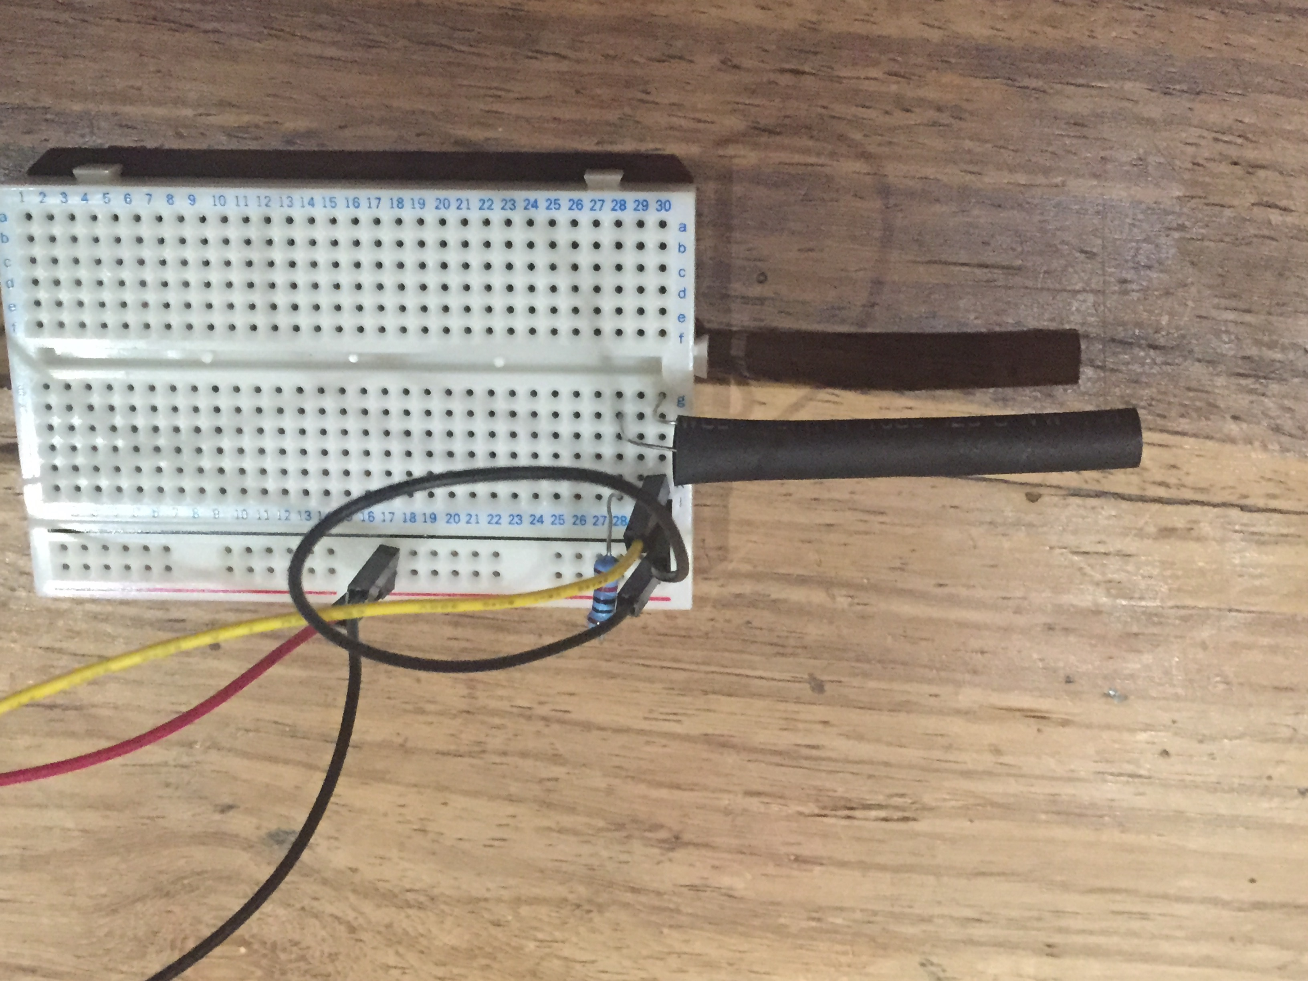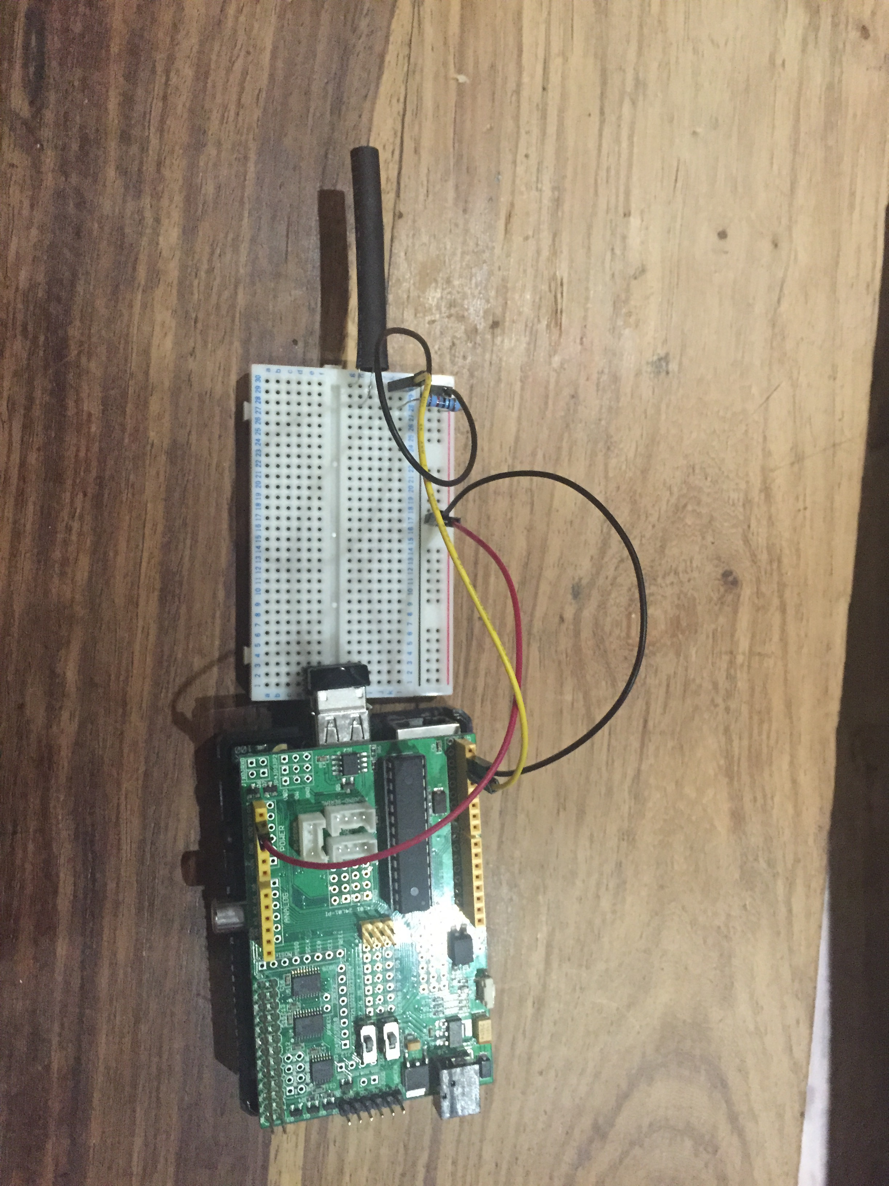

### 12. Helpful links

Below you can find some helpful links that can be used in this project.

* Raspberry Pi Foundation : <https://www.raspberrypi.org/>
* Debian WiFi : <https://wiki.debian.org/WiFi>
* Clickatell : <https://www.clickatell.com>